AT 2.2

The specifications for this program were retrieved from South Metropolitan TAFE Blackboard website.

The requirements were issued as follows:

* You are required to make a staff name-ordering list for payroll.
* You need to create a balanced binary search tree for a dictionary of no less than 10 words.
* You must be able to:
  + Search the list
  + Add to the list
  + Remove from the list

|  |  |  |  |
| --- | --- | --- | --- |
| Case | Expected Result | Actual Result | Screenshot/Images |
| Add valid name to list | Valid name entered in correct order. | As Expected. | 1.1, 1.2 |
| Add invalid name (whitespace) to list | Name not entered. | As Expected. | 2 |
| Remove valid name from list | Name removed. | As Expected. | 3.1, 3.2 |
| Unbalance table by addition | Table rebalanced. | As Expected. | 4.1, 4.2, 7.2, 7.1 |
| Unbalance table by deletion | Table rebalanced. | As Expected. | 5.1, 5.2 |
| Remove invalid name from list | Name not removed. | As Expected. | 6.1, 6.2 |

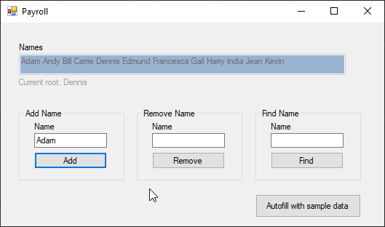

Figure .1

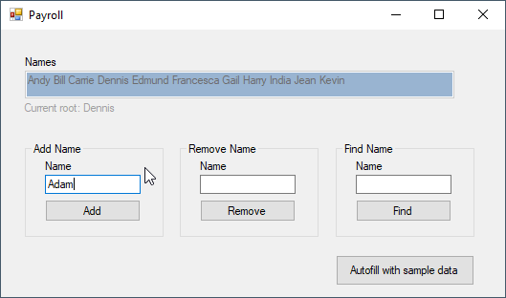

Figure 1.2

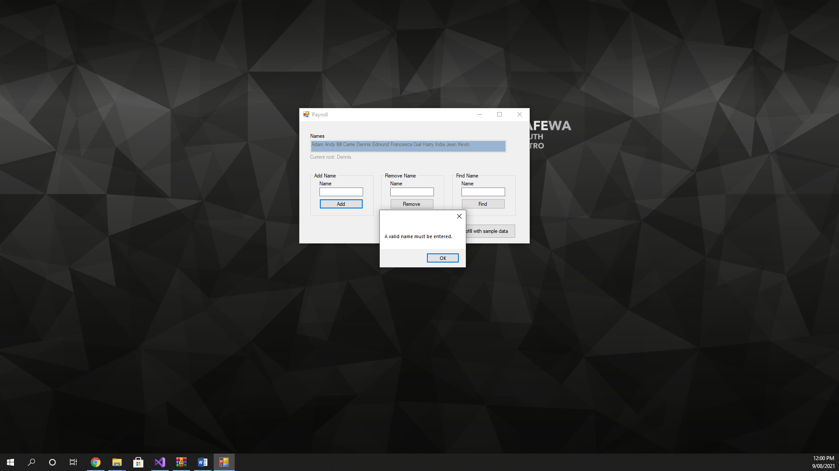

Figure

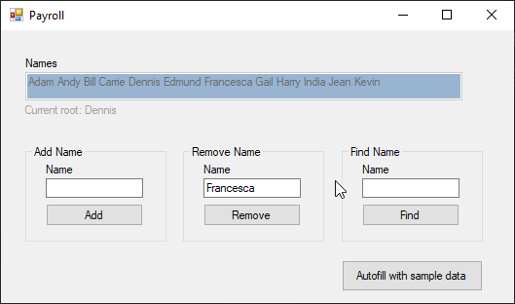

Figure .1

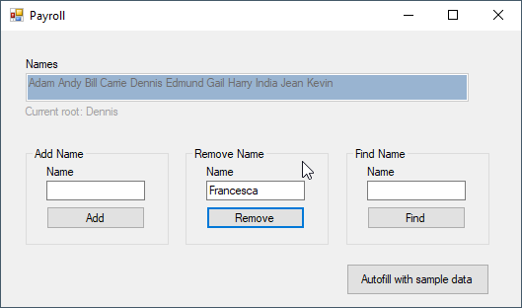

Figure 3.2

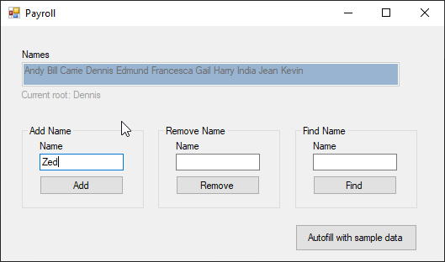

Figure .1

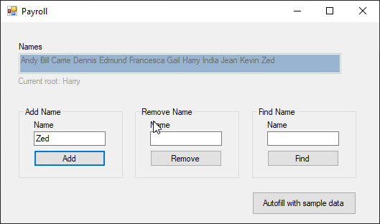

Figure 4.2

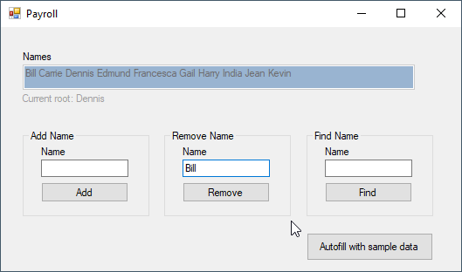

Figure .1

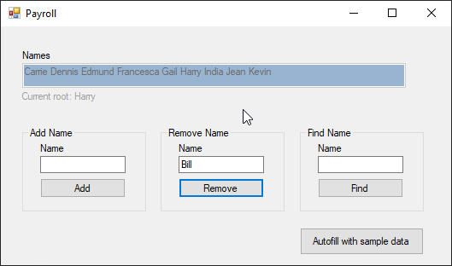

Figure 5.2

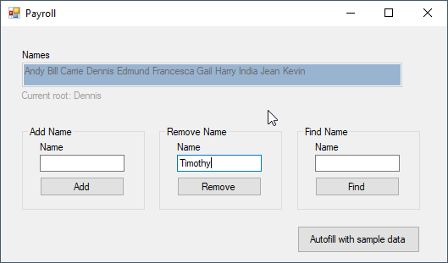

Figure .1

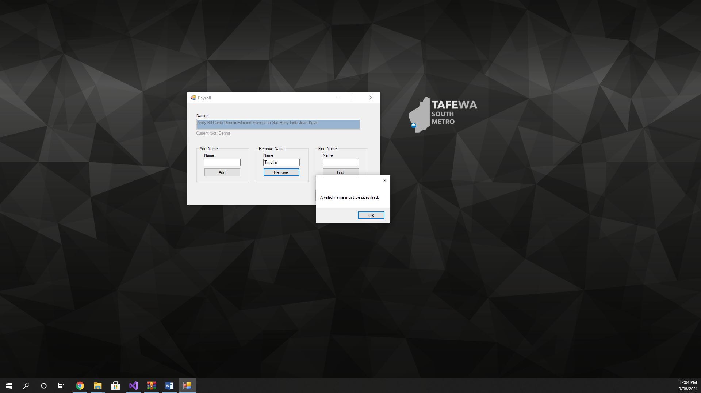

Figure 6.2

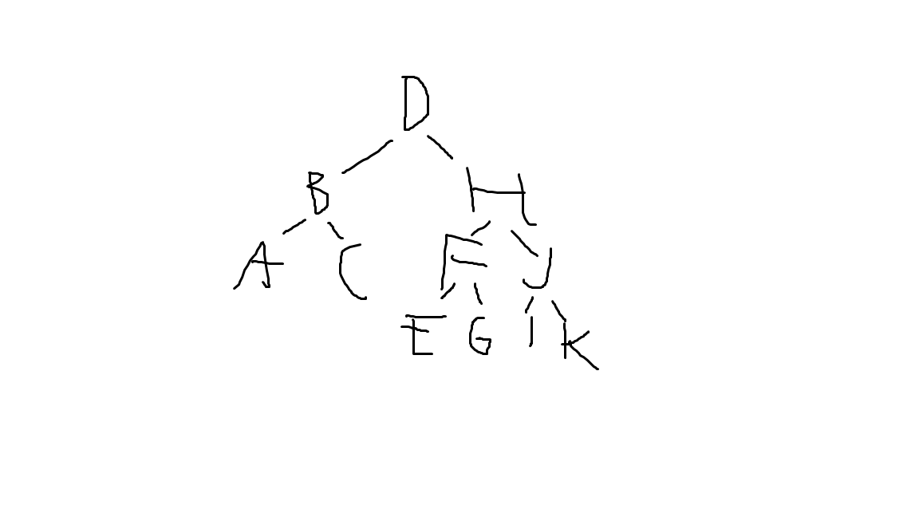

Figure .1

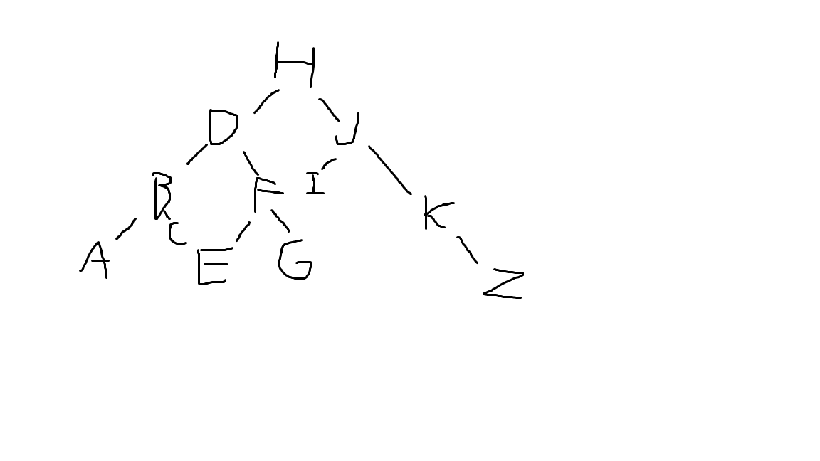

Figure 7.2